**Unity API (QOL API, Timescale, Vector3 Methods, Unity UI)**

**LAB # 7**



**Fall 2024**

**CSE-411L Intro to Game Development Lab**

Submitted by: **Ali Asghar**

Registration No.: **21PWCSE2059**

Class Section: **A**

“On my honor, as student of University of Engineering and Technology, I have neither given nor received unauthorized assistance on this academic work.”

Submitted to:

**Engr. Abdullah Hamid**

Date:

**24th December 2024**

**Department of Computer Systems Engineering**

**University of Engineering and Technology, Peshawar**

**Objective:**

In this lab we further explored the Unity API.

**Tasks:**

1. **Open or create a Unity scene.**
2. **Create a player cube.**
   * Implement movement controls for the player cube using the axis input. This should allow the player to move forward, backward, left, and right.
3. **Set up the camera.**
   * Configure the camera to a top-down view, providing a bird's-eye perspective of the scene.
4. **Instantiate enemy cubes.**
   * After a 3-second interval, randomly instantiate enemy cubes on the plane.
   * Ensure that the instantiation process is confined to the plane's boundaries.
5. **Initialize game objects.**
   * At the start of the game:
     + Set the player cube's color to blue.
     + Set the enemy cubes' color to red.
     + Initiate enemy movement towards the player.
6. **Implement game over condition.**
   * When an enemy collides with the player:
     + Pause the game.
     + Display a "Game Over" message on the screen.
7. **Handle enemy interaction.**
   * When an enemy is clicked:
     + Stop the enemy's movement.
     + Destroy the enemy after a 1-second delay.
8. **Implement a score system.**
   * Display the current score on the screen.
   * Increment the score each time an enemy is destroyed.

**Code:**

**EnemySpawner.cs**

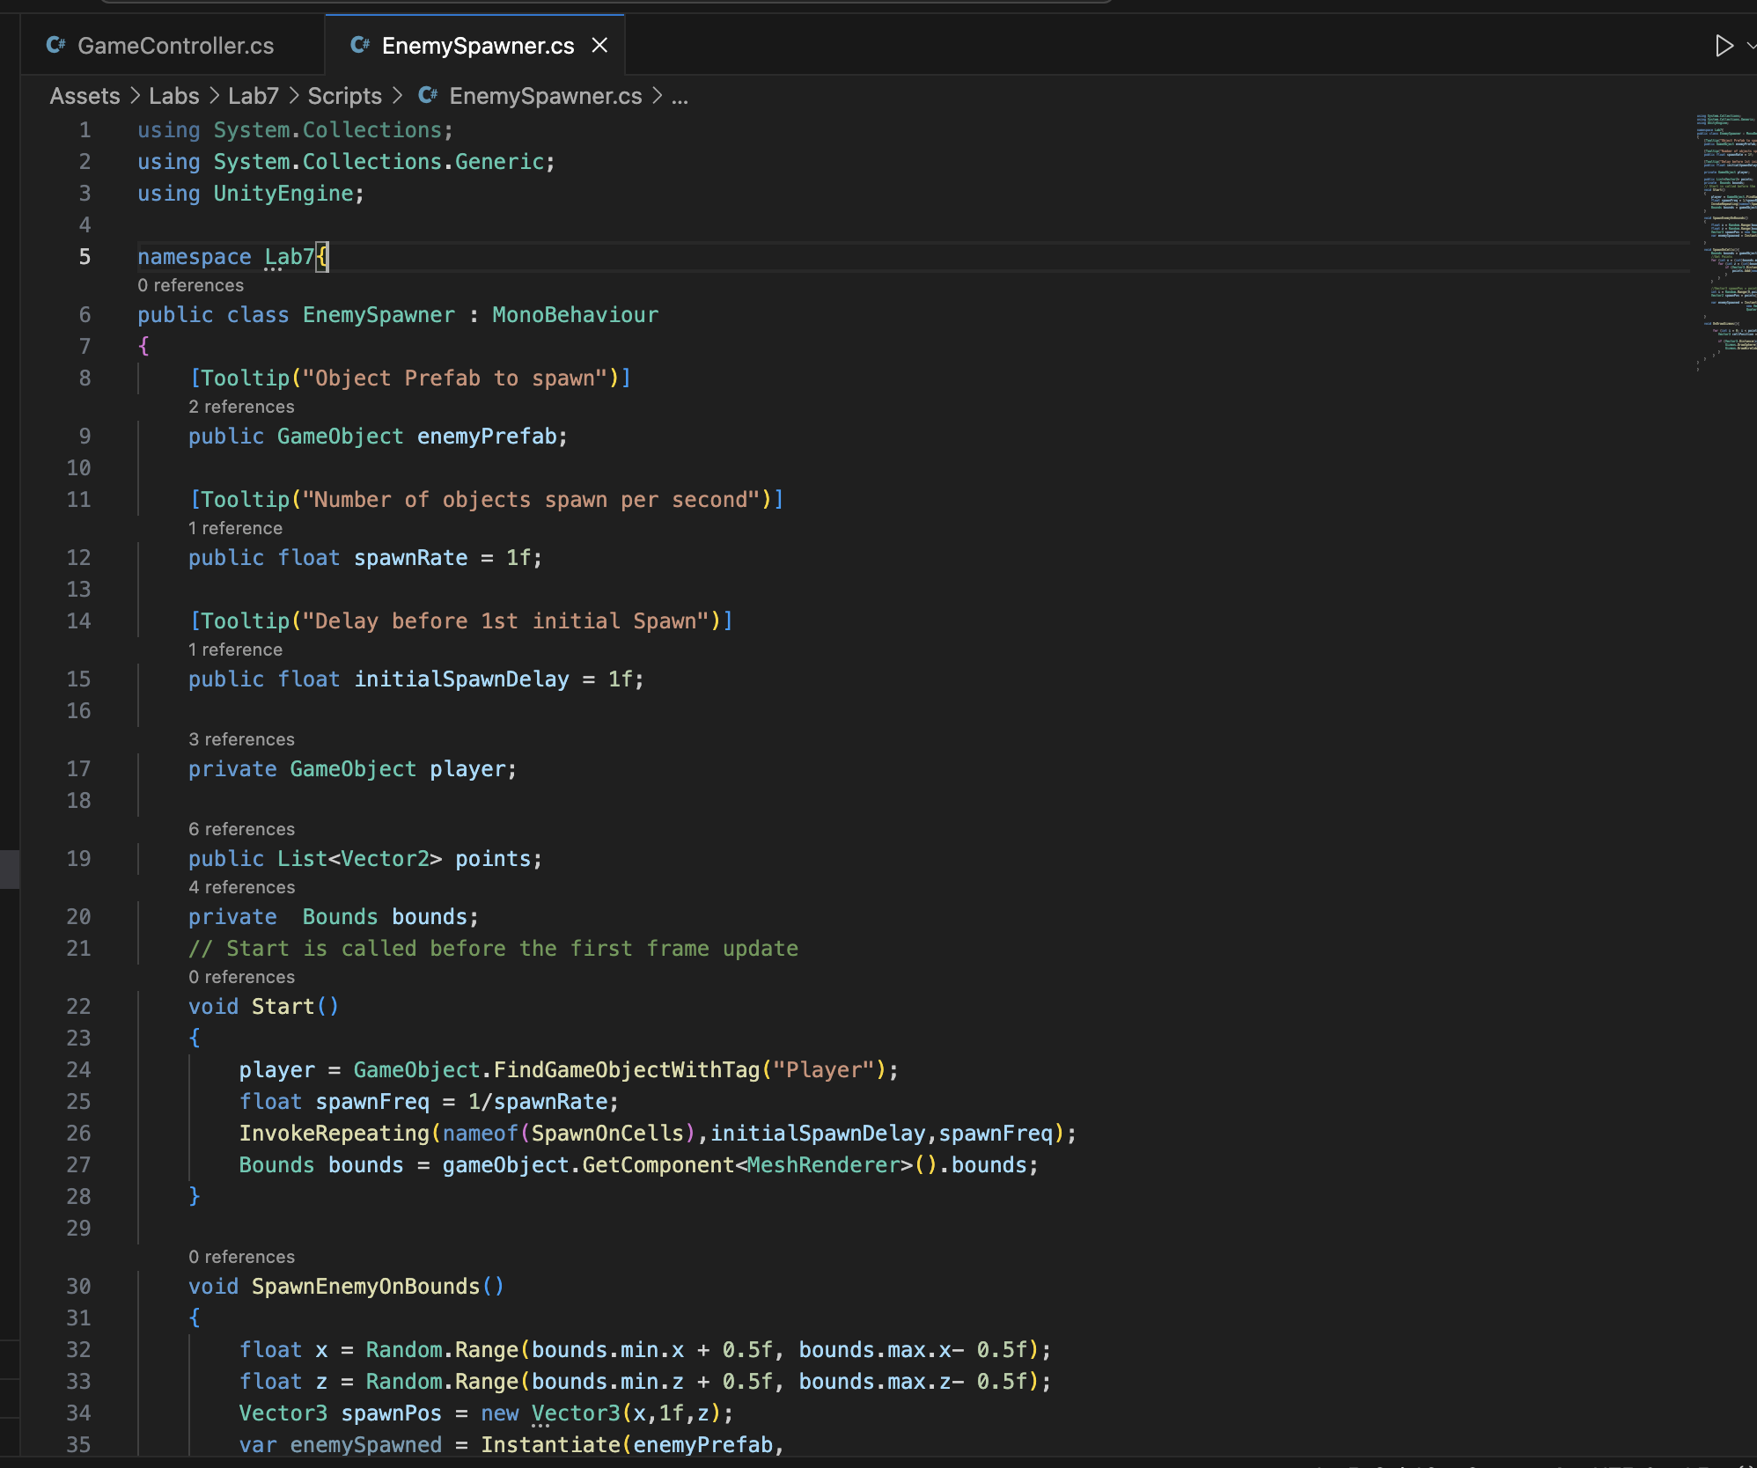

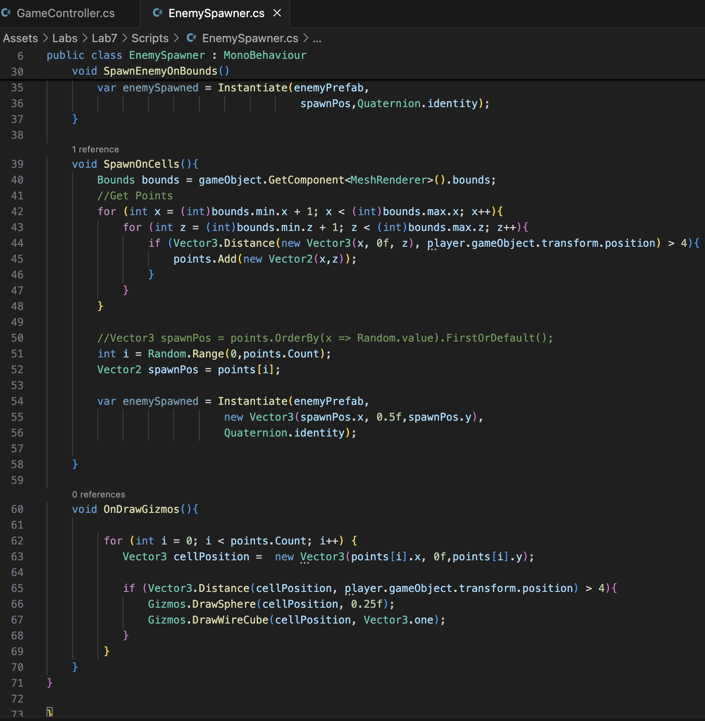

**GameController.cs**

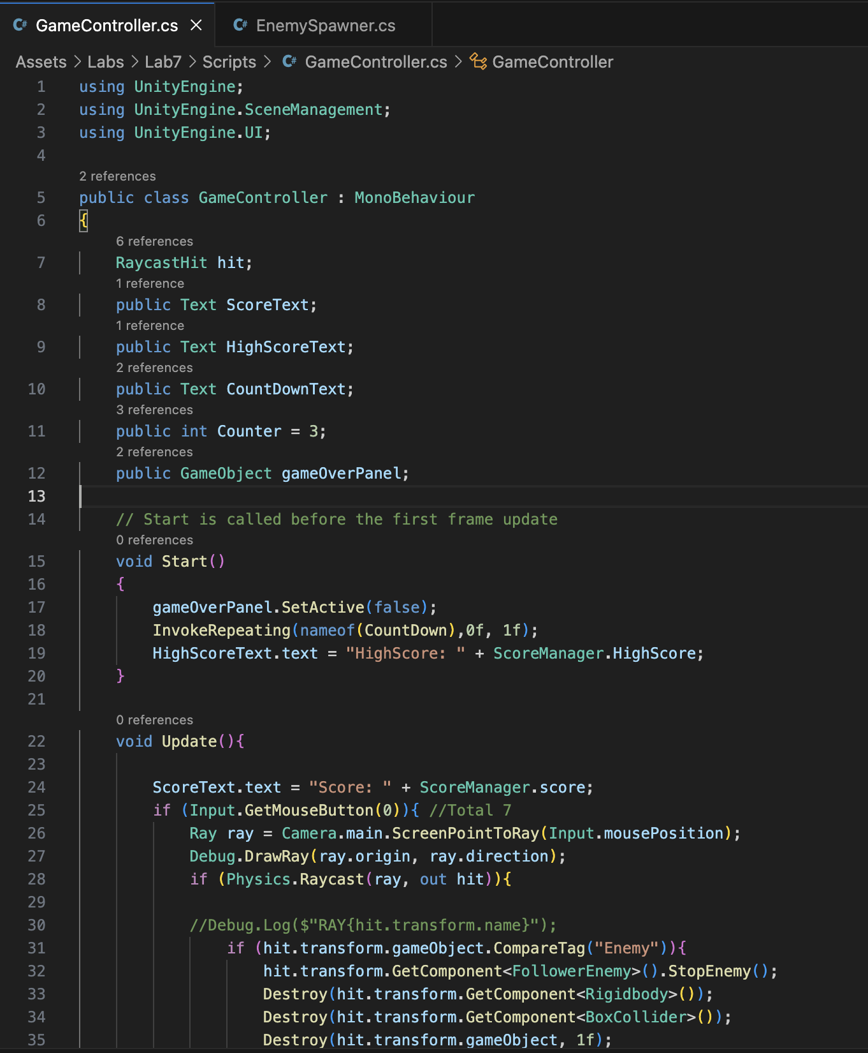

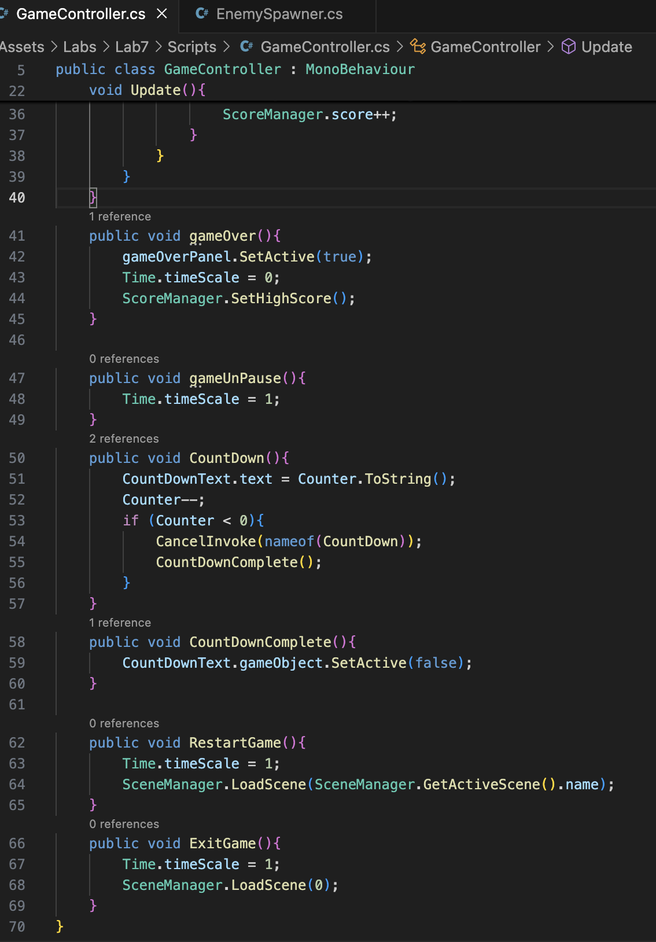

**Player.cs**

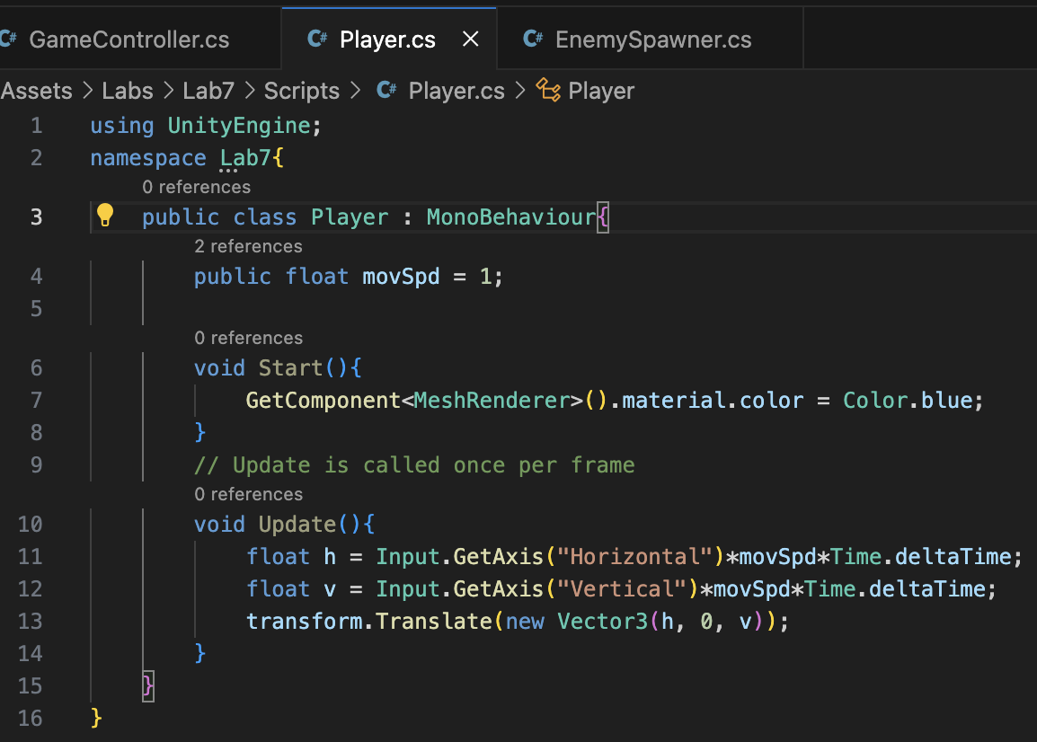

**Output:**

